**Alekhya Krishna Balivada Python Day 3 Assessment-3(14-12-2023)**

**Loop Control Statements:** Loop control statements are used to change the flow of execution. These can be used if you wish to skip an iteration or stop the execution. The 3 types of loop control statements in python are break statement, continue statement and pass statement.

1. **Break Statement :** In python, break allows us to exit a loop when an external condition is met.

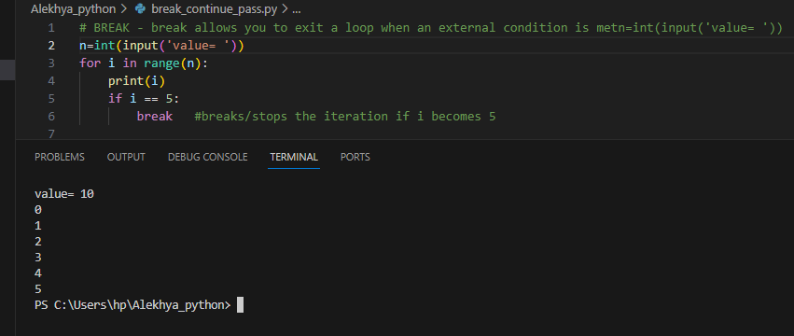

1. **Continue Statement:** In python, continue statement is used to skip the remaining code inside a loop for the current iteration only.

* Skips the particular condition and continues the loop.

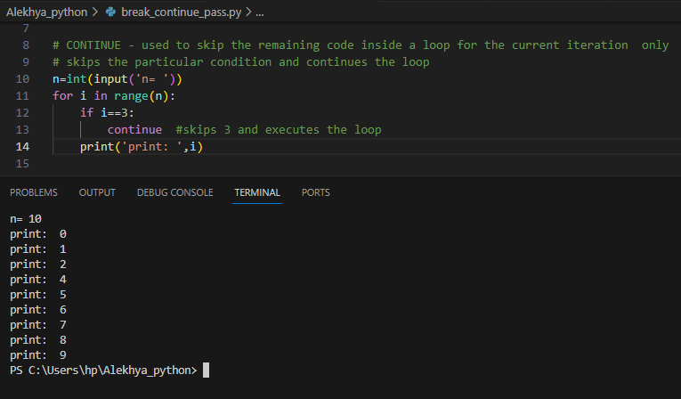

1. **Pass Statement :** In python, pass statement is used as a null statement which can be used as a place holder for future codes.

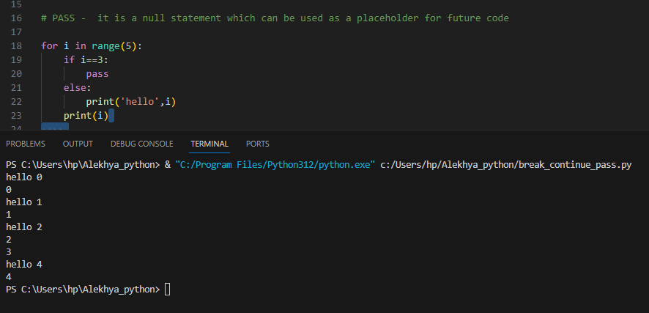

**Data Structures:** Data structures are containers that organize and group data according to type. The data structures doffer based on mutability and order..

* The basic python data structures in python include List, Set, Tuple and Dictionary. Each of the data structures is unique in its own way.

1. **List :** A List is a data structure in python that is mutable/changeable and ordered sequence of elements.

**List Slicing :** In order to access a range of elements in a list we need to slice a list. We use slicing operator i.e., colon(:) for slicing the list.

List slicing – Lst[ start_index : end_index : index_jump]

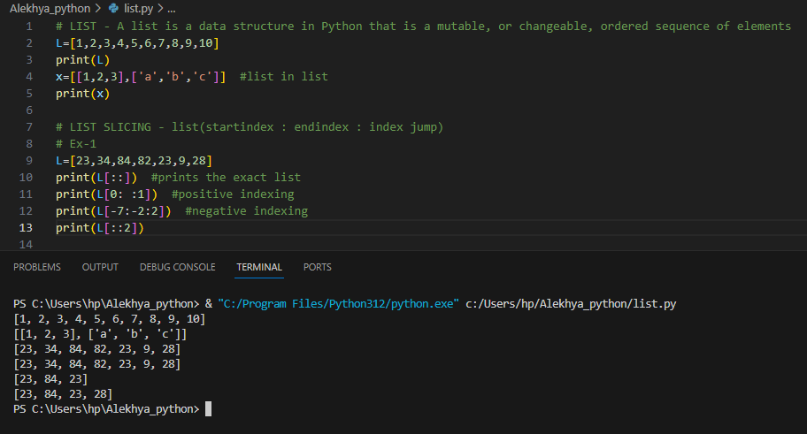

**List Methods :**

1. Append( ) : Adds an element to the end of the list.
2. Extend( ) : Adds more than one element to the end of the list.
3. Remove( ) : Removes the element from the list.
4. Insert( ) : Adds the element between the list.
5. Pop( ) : Removes the last element from the list.
6. Len( ) : Returns the length of the list.
7. Max( ) : Returns the maximum element from the list.
8. Min( ) : Returns the minimum element from the list.
9. Reverse( ) : Returns the list in reverse order.
10. Copy( ) : Returns the copy of a list.
11. Count( ) : Counts the number of times an element occurs.
12. Concatenation : Combines 2 lists.
13. Sort( ) : Returns the sorted list in ascending order.
14. Clear( ) : Clears the elements in the list.
15. Index( ) : Returns the index of the element from the list.